Political Science 365 Contemporary International Politics
Fall, 2019 Professor Volgy
Tuesdays/Thursdays, 9:30-10:45 Social Sciences 222

Syllabus

Office Hours: Wednesday/Thursday 11:30-1:00 and by appointment.
Office: Social Sciences 330
E-mail: volgy@email.arizona.edu
Web page: http://www.volgy.org

GOALS:
Although the title of this course indicates that this class is about contemporary international politics, that title should not lead you to think that the course is about today’s current events. While current events and recent history will be used to illustrate the general trends in the course, the major goal here is to develop our abilities to think critically about international politics through an examination of a number of important, general principles regarding how international politics work, and with which we can understand both “contemporary”, past, and future events and phenomena.
APPROACHES TO THIS COURSE:
There are two general approaches used for understanding the contents of this course. One is traditional: trying to focus on the subject by virtue of the common readings, class discussions and class lectures (occasional). The second approach will have us utilize these materials in a more concrete way by applying them to more specific situations. This second approach is based on a role playing method and it will involve the following steps:
- Each student is asked to choose a specific “group” and a “role” to play within the group. On the basis of these choices, students will be placed into groups (usually countries) and into specific roles within these groups.

- Each group in the class will be asked to do some research on the group, and to present the research in writing. This occurs in two phases, as is noted below.

- Groups will be asked to play out their roles. As we move through the course, and each group develops expertise about itself, members of the group will be called upon in class to blend their expertise with the generalizations we are discussing during a particular week. For example, when we discuss nationalism, we may ask the French group to respond to the question of how French nationalism affects French foreign policy.

GRADES:
Grades will be based on the following:
Exams: there will be a midterm and a final exam. Together they will be worth 50% of the course grade;
Role playing involvement: the combination of your research, written presentation, and role performance will be worth 40% of the course grade;
Class participation: the quality of your class participation will be worth 10% of the course grade. In order to assist you with your class participation, the weekly course focus on the syllabus includes a number of questions to think about in the context of the readings. You should think about those questions before coming to class and be ready to discuss your answers to those questions in class. Class attendance is mandatory: if you don’t think you can come to class every time it meets, then you should not be taking this course! University policy regarding grades and grading systems is available at: http://catalog.arizona.edu/2015-16/policies/grade.htm

EXPECTATIONS:
Examination policy: There will be two exams in the course and their times and dates are listed in the syllabus. Therefore, I assume that you will plan your schedule accordingly, and will take these exams when they are scheduled. If you cannot—for any reason—attend the midterm or the final, you must notify me at least one week prior to the exam. I will not give make-up exams unless your inability to take the exam involved an extremely unusual hardship or unavoidable circumstance.
Attendance policy: I consider discussion in this class, and the occasional lectures you will hear to be a crucial component of this course. Furthermore, the parts of the class focusing on role playing are essential to your grade. Just as important, this course meets only twice a week; this means that missing one class means missing a substantial amount of the content of this course. Missing class will mean that it will be virtually impossible for you to do well in the course. It is assumed that you will come to every class. There will be an attendance list circulating during most class sessions. Students who miss class due to illness or emergency are required to bring documentation from their healthcare provider or other relevant, professional third parties. Failure to submit third-party documentation will result in unexcused absences. The UA’s policy concerning class attendance is available at: http://catalog.arizona.edu/2015-16/policies/classatten.htm. Absences pre-approved by the UA Dean of Students (or Dean designee) will be honored. See http://hr.arizona.edu/policy/appointed-personnel/7.04.02. The UA policy regarding absences on and accommodation of religious holidays is available at http://deanofstudents.arizona.edu/policies-and-codes/accommodation-religious-observance-and-practice.
Role playing: Every person in this course will be assigned a role, and will be part of a group. Both the preparation for, and the role playing itself will require you to work with others in collaboration. That is also how international politics work and foreign policies are developed and conducted. Sometimes, however, this leads some students to think that they can slack off and let the other members of the group take up the extra work. Warning: it won’t work. You will be doing a tremendous disservice to yourself, and to other members of the group, and ultimately, it will be reflected in your grade. In this class you will have to work with others; learn to depend on others; and allow them to depend on you as well.
Withdrawal policy: Technically, the university allows students a number of weeks before they can no longer withdraw from a course. Unfortunately, in this class it is a luxury that we do not have. Since you will be working with a group, withdrawal at a later date will cause no amount of grief for the rest of your group. Therefore, I will not allow withdrawals from the course after September 5th, unless there is a very unusual circumstance.
Plagiarism: There is nothing worse at a university than the theft of someone’s work. Plagiarism comes in many forms, including paying for a paper one didn’t write, copying someone else’s work, failing to appropriately cite the work or ideas of another. All of these actions have strong negative consequences, including failing the course, and the possibility of expulsion from the University. Given these risks, (irrespective of the ethical issues involved), and the likelihood that one will get caught, it doesn’t make sense to plagiarize. The University’s plagiarism policy is located at: http://deanofstudents.arizona.edu/academic-integrity/students/academic-integrity. Assistance with what is and what is not plagiarism is provided at: http://www.library.arizona.edu/help/tutorials/plagiarism/
Other issues: I hope I don’t need to remind you of this, but just in case, it is expected that we treat each other with respect and dignity. University policies regarding these issues can be found at: http://policy.arizona.edu/human-resources/nondiscrimination-and-anti-harassment-policy and at: http://policy.arizona.edu/education-and-student-affairs/threatening-behavior-students . Additionally, respect for all of us includes not coming to class late and interrupting others; turning off cell phones before arriving to class, not using laptops during class session for anything unrelated specifically to the materials being addressed that day in class, etc.
You will see that often I will use power points and a power point projector. I do this only because I have terrible handwriting and my scribbling on the board is difficult to read. So, it is a short-hand for what we are discussing. WARNING: there is nothing more dangerous than power points for learning…they are just an outline of ideas or a shorthand for ideas, not the ideas themselves. So, please be careful with them, and take notes on the ideas behind the outline. This is also why I don’t put the power points on my web page and please don’t ask for a copy of them
On another note: if you need assistance or looking for support with special needs, they can be located at either the S.A.L.T center (http://www.salt.arizona.edu/) or at the Disability Resources center (http://drc.arizona.edu/). It is the University’s goal that learning experiences be as accessible as possible. If you anticipate or experience physical or academic barriers based on disability or pregnancy, please let me know immediately so that we can discuss options. You are also welcome to contact Disability Resources (520-621-3268) to establish reasonable accommodations. Please be aware that the accessible table and chairs in this room should remain available for students who find that standard classroom seating is not usable.

FINALLY: Please keep in mind that the syllabus acts as a contract between the faculty member and the student. By taking this course, you agree to read the requirements noted in the syllabus and agree to abide by them. By passing out the syllabus, likewise I agree to its terms with you. Changes to the syllabus then should only occur through mutual consent, and both instructor and student agree to act accordingly.
Calendar of Readings and Assignments
Reading Materials:
The “text” I was going to ask you to buy is outrageously expensive and not worth the cost. As a result, there is no text in this course and nearly all the required readings are available on my web page, at http://www.volgy.org Go to the menu options, click Courses, go to Pol 365 and then you will see all the readings listed under Pol 365. Each of the readings are listed in the order that they are assigned, and all you have to do is click on a specific reading…it will download…and then you can read it. A very few of the readings could not be downloaded but their url is listed at the end of the citation. In that case, you simply need to google the article, or cut and paste the url I noted. For example, during Week 4, I asked you to read: Barnett, 2013. “The Pentagon’s New Map.” Esquire (you can read it at: http://www.esquire.com/news-politics/a1546/thomas-barnett-iraq-war-primer/. This means it could not be downloaded, but by clicking on the url address, you should find the article. If it has moved, then you can cut and paste the title and it will appear.
REMINDER: Note that all these readings, along with other pertinent materials, are available on my web page, not on D2L. For reasons I will explain in class, I do not use D2L for my courses.
Additionally, there are some other materials of value for you. Links to useful Internet sources are contained in the appendix of this syllabus but additional, further resources are also available on my web page under the “Resources” page.
I strongly suggest as well (but will not require) that you get a subscription to the New York Times (alternatively, you can access it electronically at www.nytimes.com).
Note that for each week’s assignment, there are one or more questions for you to think about as you read the assigned readings and think about the topic. Please be prepared to discuss these questions in class. Also, note that most weeks contain two subjects and two sets of readings and questions.

DATE TOPIC and READINGS
Week 1
(August 27) Introduction to course: objectives and requirements
------------------------------------------------

(August 29) Introduction to approaches, nature of international politics

Questions: 1) What’s the security dilemma?
2) What does Waltz mean by anarchy?
3) What is Wendt’s answer?

READINGS: Waltz, 2000. “Structural Realism After the Cold War.” International Security
Wendt, 1992. “Anarchy is What States Make of it.” International Organization
(optional) Jervis, 1978. “Cooperation Under the Security Dilemma.” World Politics
-----------------------------------------------------------------------------------------------------------------
Week 2
(September 3) Methods of Control: Some Vital Concepts
Questions: 1) What is power (see appendix 1A through 1C)?
2) Which is the most powerful nation today? The second most powerful?
3) Which is the least powerful nation today?

READINGS: Walt, 2005. “Taming American Power.” Foreign Affairs
Nye, 2002. “The Limits of American Power.” Political Science Quarterly
----------------------------------------------------
(September 5) The Impact of Domestic Factors on International Politics
Questions: 1) See the scenario and question in appendix 2.
2) How much does it matter for Russian foreign policy if Medvedev governs instead of Putin? Would you say the same about the change in leadership in the United Kingdom from the Tory to the Labour government?

READINGS: Morrell (2019) “On Putin and Governance in Russia.” CBS
McCahill, 2017 “The Chinese Communists’ New Politburo Standing Committee.” NBR Commentary.
Dyson, Raleigh 2014 “Public and Private Beliefs of Political Leaders,” Research and Politics
--------------------------------------------------------------------------------------------------------------------
Week 3
(September 10) Formulating Foreign Policy: How Decisions Are Made
Questions: 1) What did the U.S. decide to do about the Cuban Missile Crisis? Why?
2) If G. W. Bush or Barak Obama had been president in 1962, would either one have made the same decision?

REDINGS: Allison, 1969. “Conceptual Models and the Cuban Missile Crisis.” APSR
Drezner, (2011) “Does Obama Have a Grand Strategy?” Foreign Affairs
Baker, (2009) “How Obama Came to Plan for Surge in Afghanistan”
-------------------------------------------------------

(September 12) Formulating Foreign Policy (continued)

-------------------------------------------------------------------------------------------------------------------
Week 4
(September 17) Defense Policy: A Special Case of Decision Making
Questions: 1) Do nuclear weapons make the world more dangerous? Why?
2) How would you go about making sure that your opponent doesn’t use nuclear weapons?

READINGS: van den Heuvel. 2015. “The New Nuclear Arms Race”
Mearsheimer and Walt, 2003. “An Unnecessary War.” Foreign Policy (you can read it at: http://foreignpolicy.com/2009/11/03/an-unnecessary-war-2/ )
Joe, 2019. “Predicting the Chinese Navy of 2030.” The Diplomat
--------------------------------------------------------

(September 19) Defense Policy (continued)
READINGS: Barnett, 2013. “The Pentagon’s New Map.” Esquire (you can read it at: http://www.esquire.com/news-politics/a1546/thomas-barnett-iraq-war-primer/ )
Smith, 2019. “Hypersonic Missiles are Unstoppable…” New York Times at https://www.nytimes.com/2019/06/19/magazine/hypersonic-missiles.html
--------------------------------------------------------------------------------------------------------------------
Week 5

(September 24) Ideology and Nationalism
Questions: 1) Can you distinguish between ideology and nationalism, giving an example of each? What makes them so different?
READINGS: Huntington, 1993. “The Clash of Civilizations?” Foreign Affairs
Kaplan, 1994. “The Coming Anarchy.” Atlantic Monthly.
Beinart, 2015. “Ideological Differences Over Terrorism” The Atlantic.
----------------------------------------
(September 26) A World of Penetrated States: Non State Actors and Terrorism in International Politics.
Questions: 1) Is international terrorism a problem for your group? Why?
2) Is there an effective way you can address this issue? (The US State Department
web site for terrorism can be accessed at: http://www.state.gov/s/ct/ ; there is also the Global Terrorism Database at: http://www.start.umd.edu/gtd/off/)

READINGS: Homer-Dixon 2003. “The Rise of Complex Terrorism.” Foreign Policy
Riedel, 2007. “Al Qaeda Strikes Back.” Foreign Affairs
Lal, 2005.“ South Asian Organized Crime and Terrorist Networks,”
Markoff et al., 2010. “Cyberwar” New York Times,
Zetter, 2012. “Meet Flame…The Massive Spy Malware…” New York Times
(optional) Galeoti 2017. “How the Kremlin Uses Russia’s Criminal Networks in Europe.” European Council on Foreign Relations

---------------------------------------------------------------------------------------------------------------Week 6
(October 1) World of Penetrated States (continued)
------------------------------------------
(October 3) International Organizations: Actors, Structures, Tools (the UN web page can be found at: http://www.un.org/).
Questions: 1) What’s wrong with the UN? What’s right with the UN?
2) Did the UN fail in Bosnia? in Iraq? in Sudan? Why?

READINGS: Barnett/Finnemore, 1999. “The Politics, Power, and Pathologies of International Organizations.” International Organization
Bird, 2001. “The IMF and Developing Countries,” in P.F. Diehl, The Politics of Global Governance (2001)
(optional) The Commission on Global Governance, “Reforming the United Nations,”

FIRST GROUP WRITTEN ASSIGNMENT DUE TODAY
---------------------------------------------------------------------------------------------------------------
Week 7
(October 8) Prepping/Discussing the Midterm Exam
---------------------------------------------------
(October 10) MIDTERM EXAM
---------------------------------------------------------------------------------------------------------------
Week 8
(October 15)
No Class this week: I’m in China for a workshop
October 17)
-----------------------------------------------------------------------------------------------------------------
Week 9
(October 22) Debriefing the Midterm Exam
---------------------------------------------------
(October 24) International Organizations (continued)
------------------------------------------------------------------------------------------------------------------
Week 10
(October 29) International Law as a Structure for Action (for an example, click on the International Criminal Tribunal on Yugoslavia at http://www.un.org/icty/)
Questions: 1) What is law? Using your definition, is there such a thing as international law? How do you know?

READINGS: Ratner, 1998. “International Law: The Trial of Global Norms.” Foreign Policy
Coplin, 1995. “International Law and Assumptions…” World Politics
----------------------------------------------------
(October 31) Alliances as Structures and Constraints/Global Architectures
Questions: 1) What is meant by bipolarity? What is meant by multipolarity?
2) What’s a hegemon? How do you know when you see one?
3) What is the major disagreement between Kagan and Maynes? Why? On what major issue do they agree?

READINGS: Brooks/Wohlforth 2002. “American Primacy in Perspective.” Foreign Affairs
Kagan, 1998. “The Benevolent Empire” Foreign Policy
Maynes, 1998. “The Perils of (and for) an Imperial America,” Foreign Policy
-----------------------------------------------------------------------------------------------------------------
Week 11
(November 5) Alliances as Structures and Constraints/Global Architectures (continued).
---------------------------------------------------
(November 7) Global versus Regional Politics: Major Powers and Regional Powers

Questions: 1) What’s a major global power? What’s a regional power? How do you know?
2) Is your group either one of those?
3) Are global and regional powers getting weaker or stronger in world politics?

READINGS: Wohlforth, “Unipolarity, Status Competition and Great Power War,” World Politics, 2009
Jentleson and Weber, “America’s Hard Sell,” Foreign Policy, 2008
---------------------------------------------------------------------------------------------------------------
Week 12

(November 12) Status Considerations in International Politics

Questions: 1) What is meant by status?
2) Why would state policy makers care about their status?

READINGS: Miller et al. “Norms, Behavioral Compliance and Status Attribution in International Politics.” International Interactions, 2015
Bezerra et al. “Going for the Gold versus Distributing the Green: Foreign Policy Substitutability and Complementarity in Status Enhancement Strategies.” Foreign Policy Analysis 2015
Larson and Shevchenko, “Status Seekers…” International Security 2010

-------------------------------------------------
(November 14) Crisis Behavior

Questions: 1) Have you ever had a crisis in your life? Why did you think of it as a “crisis”? What’s a crisis?
READINGS: Holsti, “Theories of Crisis Decision-making,”

NOTE: second part of written group assignment due today
----------------------------------------------------------------------------------------------------------------
Week 13
(November 19) Negotiations and Bargaining.
Questions: 1) How appropriate is the analogy of poker for the process of bargaining? Where does it fit, and where doesn’t it?
2) Look carefully at the Sicherman piece on “Next Steps…” Who are the key players bargaining in the Middle East? Who has most to lose? Least?

READINGS: Morgenstern, “Cold War as Cold Poker,”
Sicherman, “Next Steps in the Middle East”
------------------------------------------------
(November 21) Global Governance Issues: How to Govern the World
Questions: 1) Who makes global public policy?
2) Over what issue areas does it get done well and in what issue areas does it get done badly, and more importantly, why?
READINGS: Williams and Bellamy “Principles, Politics and Prudence: Libya and the Responsibility to Protect,” Global Governance (2012)
Nishihata, “Global Governance and the Spread of Cyberspace Controls,” Global Governance (2012)
-------------------------------------------------------------------------------------------------------------------
Week 14
(November 26) NO CLASS: Thanksgiving Recess
November 28)
--------------------------------------------------------------------------------------------------------------------

Week 15
(December 3) What makes for conflicts between states? Monadic and Dyadic Perspectives
Questions: 1) Is there a “democratic peace”? What is it? Why would it occur?
2) Is there a Capitalist peace?
3) Is there a “territorial peace”?
READINGS: Byman et al. “The Democratic Peace Idea,” in The Emergence of Peer Competitors, 2001
Gartzke, “The Capitalist Peace.” American Journal of Political Science, 2007
Gibler, “Democracies and the Territorial Peace, The Monkey Cage, 2012
---------------------------------------------------
(December 5) What makes for conflicts between states? Regional Perspectives
Questions: 1) What’s the most conflictual region in international politics?
2) What’s the least conflictual region in international politics?
3) Why?
READINGS: Acharya, “The emerging regional architecture of world politics.” World Politics, 2007
Destradi, “Regional Powers and their strategies,” Review of International Studies, 2010
-------------------------------------------------------------------------------------------------------------------
Week 16
(December 10) Course Wrap-up and Discussion of Final Exam

-------------------------------------------------------------------------------------------------------------------
Final Exam: December 17, 8:00 AM
APPENDIX 1A POWER RANKINGS

Rank | Military Spending | Armed Forces | GDP | GDP per Capita | Exporters | Importers | Most traded Currencies | Top 20 Universities
1 | United States | China | United States | Luxembourg | China | United States | United States(44%) | United States(75%)
2 | China | India | China | Switzerland | United States | China | EU (16% | UK (20%)
3 | Saudi Arabia | United States | Japan | Qatar | Germany | Germany | Japan (11%) | Switzerland (5%)
4 | Russia | N. Korea | Germany | Norway | Japan | Japan | UK (7%)
5 | United Kingdom | Russia | UK | United States | South Korea | UK | Australia (3.5%
6 | France | Pakistan | France | Iceland | France | France | Canada (2.65)
7 | Japan | S. Korea | Brazil | Singapore | Netherlands | S. Korea | Swiss (2.5%)
8 | India | Iran | Italy | Denmark | Russia | India | China (2%)
9 | Germany | Vietnam | India | Australia | UK | Netherlands | Sweden (1.1%)
10 |  | Egypt | Russia | Sweden | Italy | Canada | Mexico (1.09%)

Appendix 1B: WHO CAN MAKE FISSILE MATERIAL TODAY/ ENRICHMENT AND REPROCESSING FACILITIES WORLDWIDE (Source: UN NPT Review Conference, May 2015)

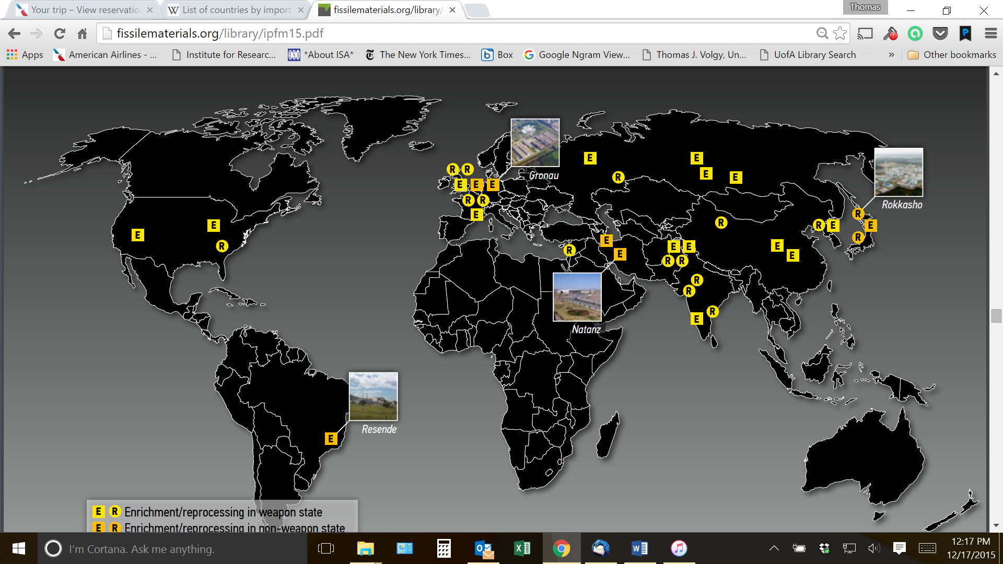

Nuclear Weapons Programs Worldwide

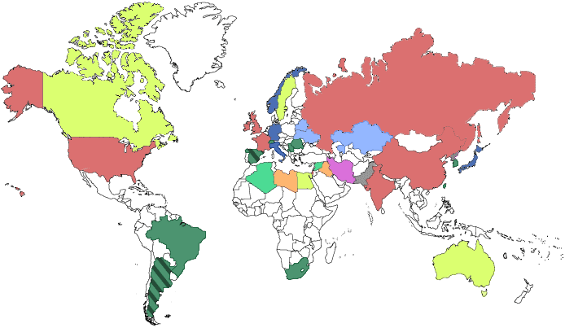Key
Nuclear weapons programs that began before 1970 when the Nuclear Non-Proliferation Treaty (NPT) came into force, succeeded, and are still ongoing
Programs that essentially ended by the time NPT started
Factions within advocated for or sought nuclear weapons, but these ambitions ended by the time NPT started
Programs that ended after 1970
Programs that started after 1970 and: Succeeded and are ongoing
Are suspected to be actively seeking nuclear weapons Are now ended
Intentions suspected but no nuclear weapons program identified
Inherited nuclear weapons, but now a non-nuclear weapon state party to the NPT

APPENDIX 2 NATIONAL SECURITY CRISIS

You have been appointed by the president of the United States to the National Security Council. This is our third meeting. Today, I have convened this meeting at the request of the President in order for us to make a recommendation to him with respect to a new, major problem facing us. Consider the following information brought to us last night:
According to our intelligence sources, Russian nuclear submarines, armed with thermonuclear weapons, have been detected off the shores of the following areas:
San Diego; San Francisco; Miami; New York; Boston.
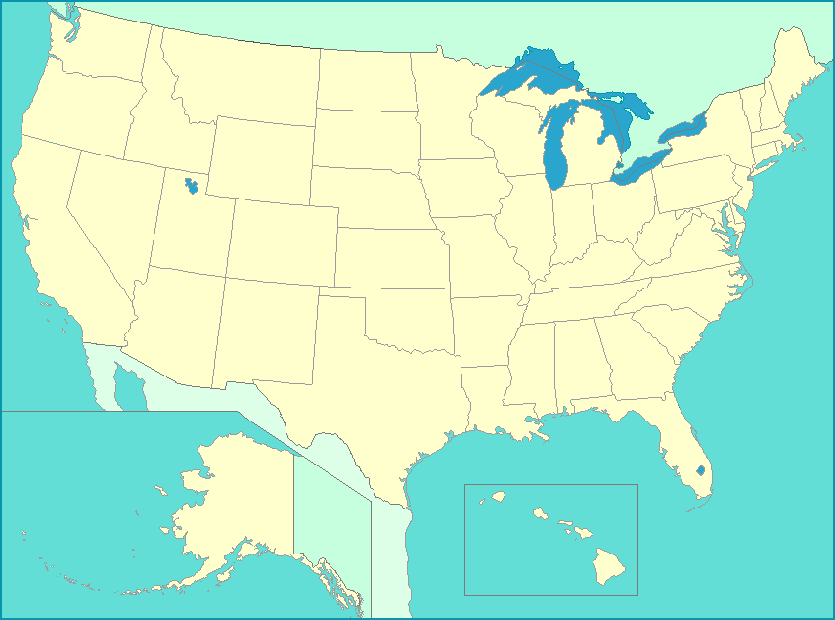

In all five cases, the submarines are within 150 nautical miles of our continental shores. Apparently, all submarines were moved into their present locations over the last forty eight hours.
The CIA, using both our capabilities, and secure Russian sources, has confirmed the placement of the submarines this morning. We also have confirmation of the missile capabilities on the submarines. This is close proximity to our continental shores, and we are not aware of a single previous instance, even during the Cold War, of any prior attempts by Russia or the former Soviet Union to attempt this pattern of deployment this close to our shores.
Thus, the situation has become a serious national security problem, and perhaps as well, a serious national security threat.
We have a request from the President for an immediate set of recommendations to him on an appropriate course of action to take.
Before we can recommend an appropriate course of action, we will need to decide what are Russian intentions. In other words, why would the Russians take this course of action? Our response to this issue will critically affect our recommendations.
I need you to answer this why question at our next meeting. Consider the situation carefully! Our national security is at stake!

APPENDIX 3 ROLE CHOICES
Below, you will find a number of groups that will be involved in role playing during the semester. Please indicate your top three preferences, in the order of your preference, by emailing them to me at volgy@email.arizona.edu, indicating your full name, and listing your preferences in order of choice (1 through 3).

Peoples Republic of China
France
Russian Federation
United Kingdom
United States
Germany
India
Republic of South Africa
Iran
Saudi Arabia
Israel
Turkey
Brazil

APPENDIX 4 ROLE ASSIGNMENTS

The first time you meet as a group, you will need to agree on who is going to play what role in your group. As you do, you will need to e-mail me those choices at volgy@email.arizona.edu . This email should be sent to me by the chief decision-maker for the group, as soon as the roles have been parsed out. In the email, please specify the following:

Name of group_________________________________

Simulation role Student’s name E-mail

___________________ _______________________ _______________ ______________

___________________ _______________________ _______________ ______________

___________________ _______________________ _______________ ______________

___________________ _______________________ _______________ ______________

___________________ _______________________ _______________ ______________

___________________ _______________________ _______________ ______________

___________________ _______________________ _______________ ______________

APPENDIX 5 ROLE PLAYING RESEARCH RESPONSIBILITIES

First Assignment:
The first assignment for each group is to divide the group into available roles for each nation. The chief decision-maker will have overall responsibility for the group (As part of the first assignment, the chief decision-maker in each group is responsible for turning in the sheet that is contained in Appendix 4. Please e-mail this information to me at: volgy@email.arizona.edu. Each member of the group should keep the information as well with respect to who plays which role and their respective phone numbers).
--------------------------------------------------------------------------
Second Assignment:
The second assignment is to learn as much about your group as possible by the end of the sixth week of class; the paper will be due on October 3rd. At a minimum, you will want to answer the following five questions:
- What seem to be the major foreign policy goals, interests, objectives of your group (be specific)? Why? Are there any particular domestic problems in your nation with strong implications for your foreign policy objectives and interests?
- Which other nations and groups seem to be your most important “friends,” “enemies”? Why? What do you mean by friends and enemies?
- To what extent do the five domestic variables (which we will discuss in class) affect the foreign policies of your country? To what extent do these domestic variables help in understanding the manner in which domestic problems in your nation are/or are not having an effect on your foreign policy objectives and interests?
- What range of resources do you have available to you to help pursue your foreign policy objectives, including military and economic capabilities (make sure you answer this question in the context of your answers to question 1)? How dependent are you on resources outside of your country?
- How important is ideology to your group? How about nationalism?

Then, toward the end of the semester (November 14th), you will want to answer the remaining questions:

- How actively are you involved with regional or global organizations and alliances? Why?
- What, if any status considerations drive your foreign policy objectives and actions?
- What is your group’s position on global climate change?
- What is your group’s position on globalized free trade?
- What is your group’s position on fighting global terrorism?

To do the research necessary to answer these questions, it is strongly advised that you work as a group and divide responsibility for the research, coordinate the effort, and pool the research each of you will pursue. In cases of groups where your research may be highly interdependent (e.g., Bosnia and Serbia, etc.), for the purposes of the research only, it is permissible for these groups to work with each other and share information during the research phase. (CAUTION: each member of the group will be held responsible for the overall group project.)
In doing your research, you will want to consult several sources, including, but not limited to the following:
- Current events sources:
Check through at least one of the following sources, for at least the last three years for your country: New York Times Index; Keesing’s Contemporary Archives; Facts on File; FBIS (Foreign Broadcast Information Service). There are current events sources for several of your nations as well on the Internet, and links are available for many on them on my web page for this course. You can also see your nation’s involvement in the UN and (indirectly perspectives of your nation’s decision makers on international relations through the General Debates of the Plenary Session of the United Nation’s General Assembly (http://www.un.org/ga/20special/ga54/IndexE.htm).
- National resources: a good world almanac of the most recent vintage. Further information is available as well from the annual volumes of the U.S. Arms Control and Disarmament Agency, SIPRI, publications of the World Bank and IMF, and the UN Yearbook of International Statistics.

- General foreign policy analysis: see these journals for articles regarding your country’s foreign policy: Foreign Policy; Foreign Affairs; World Politics Review

- Faculty resources: there are a number of faculty who have expertise in your area, both in the political science department, and in other departments on campus. You may wish to chat with them. Caution: don’t go unprepared! If you want their help, have very specific question ready to ask of them.

- Some additional quality internet sites:
WWW Virtual Library: International Affairs Resources (http://www.etown.edu/vl/)
MSU Global Access (http://www.msuglobalaccess.net)
International Relations and Security Network (http://www.isn.ethz.ch)
World Politics Review (http://www.worldpoliticsreview.com)
Stratfor Global Intelligence (http://www.stratfor.com)
For current events on Russia, see http://russialist.org/ and if you wish, you can subscribe for free to Johnson’s Russia list, which send people (several times a week) commentary on Russian domestic and foreign policy. You can subscribe by sending a message to davidjohnson@starpower.net
---------------------------------------------------------------------------------------------
CAUTION: keep a list of references, in a separate WORD file. These you will need to turn in at the end of the semester. They will have to reflect the full array of references you used in compiling the paper, and any other references you read after you had submitted the paper as you are updating your knowledge of your group and your role. The references are due at on the last day of classes (one set of references from each group)
----------------------------------------------------------------
Third Assignment: Realistically participate in role playing (more on this later, including role playing rules)
----------------------------------------------------------
Fourth Assignment: (due no later than December 10th, via e-mail, to me): An evaluation of your performance and that of each other member of your group (See Appendix 6).

APPENDIX 6 ROLE EVALUATION: INDIVIDUAL ASSIGNMENTS

Evaluate your own participation in your group. How helpful were you to others in the group? How much did you personally contribute to the group’s performance? How well did you integrate and apply the materials we had discussed in class to your own group?

Evaluate each one of the other members of your group separately, using the same questions which you used to evaluate yourself.

On the basis of these evaluations, assign a letter grade to yourself, and to each other member of the group.

(This assignment is due December 10th. Send the evaluation to me, as an attachment, in WORD, to my email address at volgy@email.arizona.edu)

