Pompeo Says Human Rights Policy Must Prioritize Property Rights and Religion
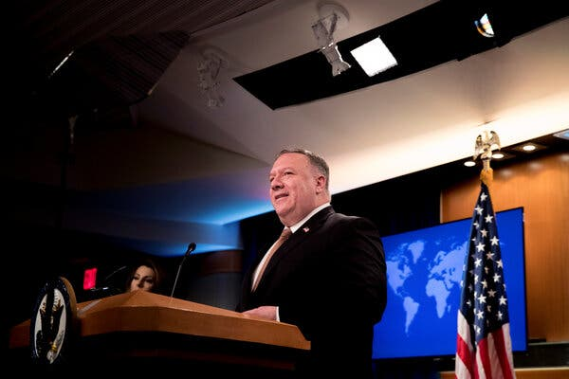

Secretary of State Mike Pompeo said that “property rights and religious liberty” were two of the most important unalienable rights envisioned by the nation’s founders.Credit...Pool photo by Andrew Harnik
By Pranshu Verma
July 16, 2020
WASHINGTON — Secretary of State Mike Pompeo delivered a divisive speech on Thursday calling for the United States to ground its human rights policy more prominently in religious liberty and property rights.
Mr. Pompeo’s speech, at the National Constitution Center in Philadelphia, came as he announced the release of a report created by a panel he commissioned last year to suggest how American human rights policy could better reflect the “nation’s founding principles.”
“It’s important for every American, and for every American diplomat, to recognize how our founders understood unalienable rights,” Mr. Pompeo said. “Foremost among these rights are property rights and religious liberty.”
Human rights scholars have criticized Mr. Pompeo’s panel since its inception, noting it was filled with conservatives who were intent on promoting views against abortion and marriage equality. Critics also warned that it sidestepped the State Department’s internal bureau responsible for promoting human rights abroad.
Experts have said that Mr. Pompeo’s efforts to prioritize religion in particular above other ideals in American diplomacy could reverse the country’s longstanding belief that “all rights are created equal” and embolden countries that persecute same-sex couples or deny women access to reproductive health services for religious reasons.
“Human rights are not a choose-your-own-adventure,” said Tarah Demant, the director of the gender, sexuality and identity program at Amnesty International U.S.A. “The U.S. State Department’s effort to cherry-pick rights in order to deny some their human rights is a dangerous political stunt that could spark a race to the bottom by human rights-abusing governments around the world.”
At the event on Thursday, which opened with a religious invocation from Cardinal Timothy M. Dolan, the archbishop of New York, Mr. Pompeo also waded into the culture war against what President Trump recently called “a merciless campaign to wipe out our history, defame our heroes, erase our values and indoctrinate our children.”
“Today, the very core of what it means to be an American, indeed the American way of life itself, is under attack,” Mr. Pompeo said. “Instead of seeking to improve America, too many leading voices promulgate hatred of our founding principles.”
He specifically criticized the 1619 Project, a New York Times initiative re-examining the legacy of slavery, describing it as part of “a dark vision of America’s birth” and a “disturbed reading of our history.”
In a statement, Eileen Murphy, a spokeswoman for The Times, responded to Mr. Pompeo’s criticism.
“The 1619 Project, based on decades of recent historical scholarship that has deepened our understanding of the country’s founding, is one of the most impactful works of journalism published last year,” she said. “We’re proud that it continues to spark a dialogue that allows us to re-examine our assumptions about the past.”
Since naming the Commission on Unalienable Rights, as his panel is called, Mr. Pompeo, an evangelical Christian, has expressed confidence that it would create a document that enshrines religious freedom as a central tenet of American human rights policy, which diplomats could refer to for “decades to come.”
But human rights scholars cautioned that this could set a global precedent for other nations to define human rights on their own terms, undermining diplomatic efforts to stop the persecution of religious minorities in places like China, or the promotion of women’s rights in countries like Iran and Saudi Arabia.
“You’re seeing the rise of autocrats across the world,” said Akila Radhakrishnan, the president of the Global Justice Center, an international human rights organization. “You’re giving a gift to those people, and not only taking away U.S. leadership, but giving them and feeding them arguments they’ve long been making as well.”
The commission is led by Mary Ann Glendon, a Harvard Law School professor and former ambassador to the Vatican. She is a prominent anti-abortion activist who has stirred controversy in recent years for making comments that awarding The Boston Globe the Pulitzer Prize for its reporting on child abuse by Catholic priests “would be like giving the Nobel Peace Prize to Osama bin Laden.”
The panel is also rooted in the vision of Robert P. George, a Princeton professor and leading proponent of “natural law” theory, a term that human rights scholars say is code for “God-given rights” and is commonly deployed in fights to roll back rights for women and L.G.B.T.Q. people.
The commission’s draft report will undergo a two-week public comment period before it becomes final.
Several human rights organizations have asked the federal court to prevent the State Department from relying on the report’s recommendations, saying the commission is unlawful because it violates federal laws requiring advisory panels to be “fairly balanced” and transparent.
Lawyers representing the State Department are expected to respond early next week.

